Andrew Stiles
CSD-430
Assignment 5 Project Part 1
10/12/2025

selectMovie.jsp:
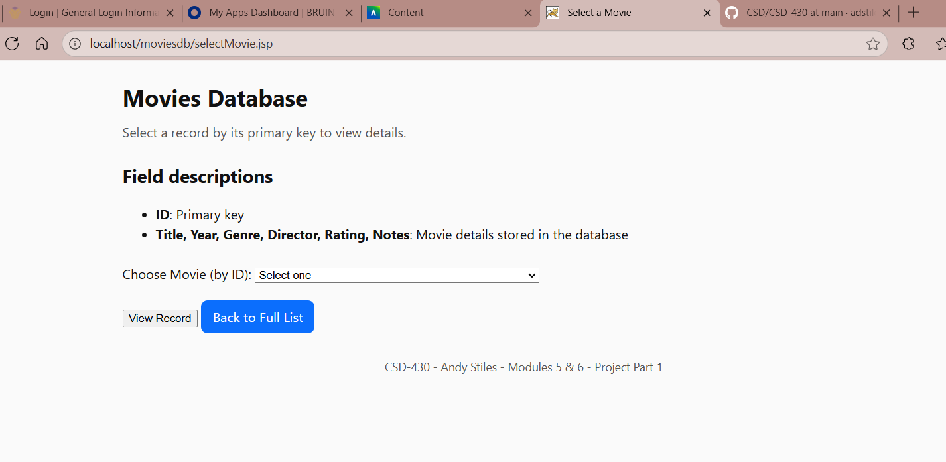

showMovie.jsp:
